Lampiran A

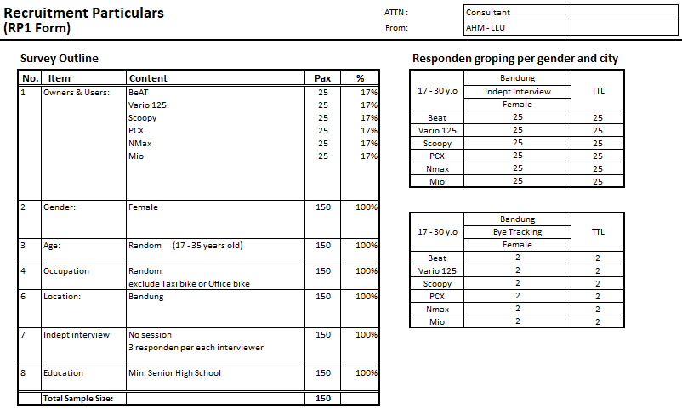

Lampiran B

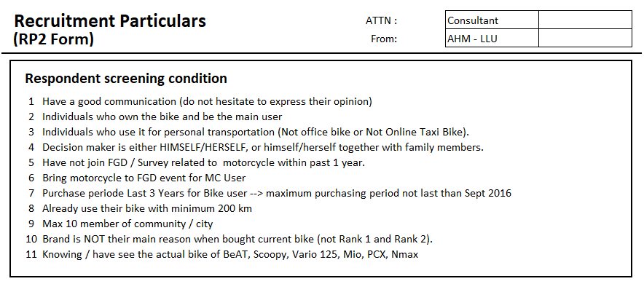

Lampiran C

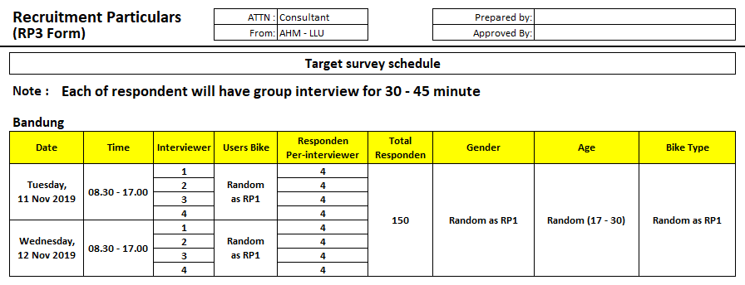

Lampiran D

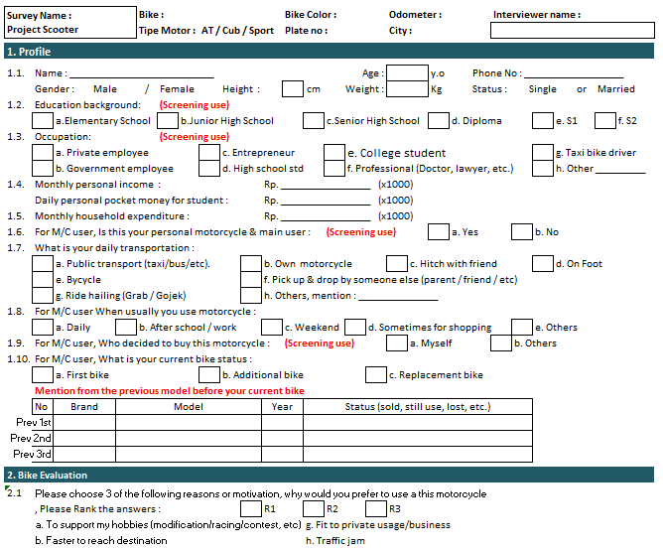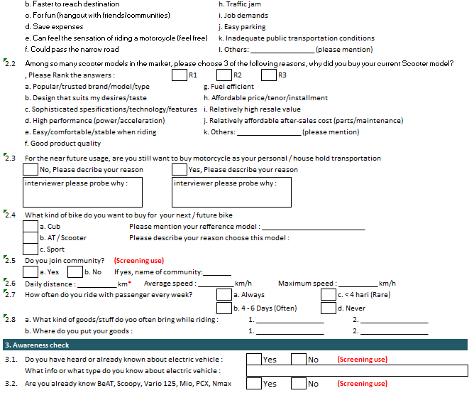

Lampiran E

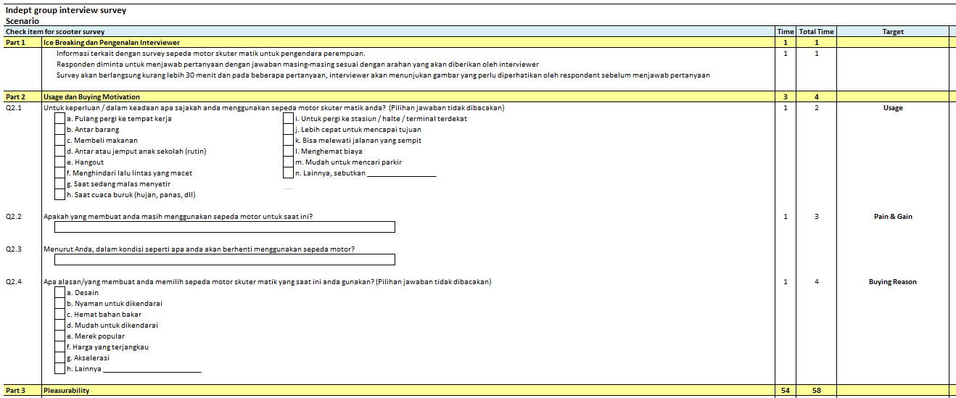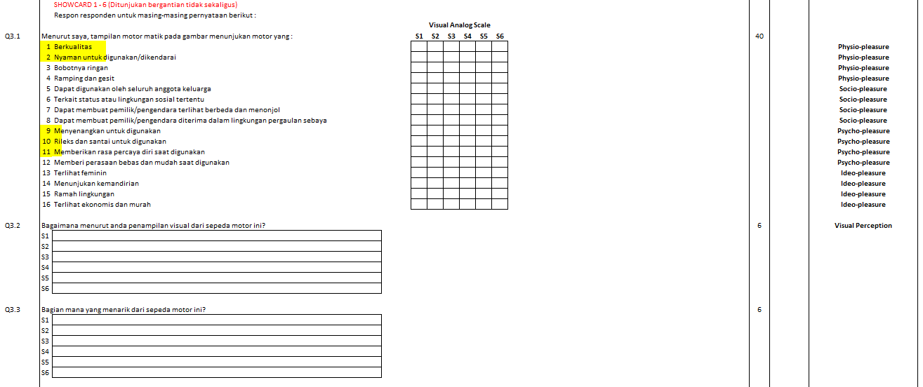

Lampiran F

Motor A

|  |  |  |  |  |
| --- | --- | --- | --- | --- |
| **Rotated Component Matrixa** | | | | |
|  | Component | | | |
| 1 | 2 | 3 | 4 |
| 1. Berkualitas | **,448** | ,323 | ,344 | -,042 |
| 1. Nyaman | ,570 | ,062 | **,663** | -,016 |
| 1. Ringan | ,089 | ,061 | **,850** | ,226 |
| 1. Ramping Gesit | ,124 | -,010 | **,886** | ,174 |
| 1. Digunakan Keluarga | **,680** | -,148 | ,019 | -,007 |
| 1. Terkait Status | -,133 | **,782** | ,113 | ,201 |
| 1. Berbeda/Menonjol | ,291 | **,802** | -,017 | -,060 |
| 1. Diterima Lingkungan | ,246 | **,758** | ,005 | ,167 |
| 1. Menyenangkan | **,673** | ,396 | ,192 | ,312 |
| 1. Relaks dan Santai | **,701** | ,261 | ,120 | ,226 |
| 1. Percaya Diri | **,779** | ,245 | ,143 | ,196 |
| 1. Bebas dan Mudah | **,675** | ,178 | ,309 | ,354 |
| 1. Feminin | ,360 | ,195 | ,131 | **,434** |
| 1. Kemandirian | ,401 | ,399 | -,010 | **,547** |
| 1. Ramah Lingkungan | ,376 | ,292 | ,073 | **,620** |
| 1. Ekonomis dan Murah | -,054 | -,094 | ,259 | **,756** |
| Extraction Method: Principal Component Analysis.  Rotation Method: Varimax with Kaiser Normalization. | | | | |
| a. Rotation converged in 7 iterations. | | | | |

Motor B

|  |  |  |
| --- | --- | --- |
| **Rotated Component Matrixa** | | |
|  | Component | |
| 1 | 2 |
| 1. Berkualitas | **,689** | ,377 |
| 1. Nyaman | **,798** | ,347 |
| 1. Ringan | **,797** | ,236 |
| 1. Ramping Gesit | **,792** | ,144 |
| 1. Digunakan Keluarga | **,668** | ,213 |
| 1. Terkait Status | ,215 | **,778** |
| 1. Berbeda/Menonjol | ,231 | **,823** |
| 1. Diterima Lingkungan | ,135 | **,832** |
| 1. Menyenangkan | **,708** | ,465 |
| 1. Relaks dan Santai | **,808** | ,380 |
| 1. Percaya Diri | ,526 | **,669** |
| 1. Bebas dan Mudah | **,757** | ,374 |
| 1. Feminin | **,626** | ,296 |
| 1. Kemandirian | ,510 | **,579** |
| 1. Ramah Lingkungan | **,616** | ,497 |
| 1. Ekonomis dan Murah | **,742** | ,058 |
| Extraction Method: Principal Component Analysis.  Rotation Method: Varimax with Kaiser Normalization. | | |
| a. Rotation converged in 3 iterations. | | |

Motor C

|  |  |  |  |
| --- | --- | --- | --- |
| **Rotated Component Matrixa** | | | |
|  | Component | | |
| 1 | 2 | 3 |
| 1. Berkualitas | **,754** | ,058 | ,260 |
| 1. Nyaman | **,699** | ,451 | ,175 |
| 1. Ringan | ,257 | **,773** | ,226 |
| 1. Ramping Gesit | ,263 | **,743** | ,136 |
| 1. Digunakan Keluarga | **,744** | ,184 | ,046 |
| 1. Terkait Status | ,234 | ,169 | **,829** |
| 1. Berbeda/Menonjol | ,235 | ,062 | **,897** |
| 1. Diterima Lingkungan | ,283 | ,126 | **,808** |
| 1. Menyenangkan | **,788** | ,307 | ,318 |
| 1. Relaks dan Santai | **,722** | ,493 | ,257 |
| 1. Percaya Diri | **,747** | ,293 | ,374 |
| 1. Bebas dan Mudah | **,700** | ,495 | ,217 |
| 1. Feminin | ,211 | **,808** | ,206 |
| 1. Kemandirian | **,628** | ,273 | ,397 |
| 1. Ramah Lingkungan | **,631** | ,371 | ,255 |
| 1. Ekonomis dan Murah | ,200 | **,574** | -,080 |
| Extraction Method: Principal Component Analysis.  Rotation Method: Varimax with Kaiser Normalization. | | | |
| a. Rotation converged in 5 iterations. | | | |

Motor D

|  |  |  |  |
| --- | --- | --- | --- |
| **Rotated Component Matrixa** | | | |
|  | Component | | |
| 1 | 2 | 3 |
| 1. Berkualitas | **,647** | -,091 | ,249 |
| 1. Nyaman | **,746** | ,251 | ,067 |
| 1. Ringan | ,145 | **,833** | ,061 |
| 1. Ramping Gesit | ,238 | **,751** | ,134 |
| 1. Digunakan Keluarga | ,147 | **,580** | ,127 |
| 1. Terkait Status | ,135 | ,106 | **,870** |
| 1. Berbeda/Menonjol | ,294 | -,101 | **,751** |
| 1. Diterima Lingkungan | ,272 | ,172 | **,817** |
| 1. Menyenangkan | **,600** | ,445 | ,193 |
| 1. Relaks dan Santai | **,848** | ,246 | ,042 |
| 1. Percaya Diri | **,660** | ,164 | ,362 |
| 1. Bebas dan Mudah | **,605** | ,427 | ,166 |
| 1. Feminin | ,388 | **,702** | ,041 |
| 1. Kemandirian | **,720** | ,213 | ,287 |
| 1. Ramah Lingkungan | **,696** | ,118 | ,198 |
| 1. Ekonomis dan Murah | -,014 | **,760** | -,144 |
| Extraction Method: Principal Component Analysis.  Rotation Method: Varimax with Kaiser Normalization. | | | |
| a. Rotation converged in 6 iterations. | | | |
|  | | | |

Motor E

|  |  |  |  |
| --- | --- | --- | --- |
| **Rotated Component Matrixa** | | | |
|  | Component | | |
| 1 | 2 | 3 |
| 1. Berkualitas | **,688** | -,157 | ,234 |
| 1. Nyaman | **,712** | ,278 | -,014 |
| 1. Ringan | ,036 | **,887** | ,045 |
| 1. Ramping Gesit | ,166 | **,858** | ,121 |
| 1. Digunakan Keluarga | ,290 | **,491** | ,130 |
| 1. Terkait Status | ,169 | ,023 | **,821** |
| 1. Berbeda/Menonjol | ,343 | -,007 | **,778** |
| 1. Diterima Lingkungan | ,252 | ,196 | **,833** |
| 1. Menyenangkan | **,850** | ,158 | ,243 |
| 1. Relaks dan Santai | **,800** | ,341 | ,065 |
| 1. Percaya Diri | **,806** | ,132 | ,354 |
| 1. Bebas dan Mudah | **,661** | ,445 | ,191 |
| 1. Feminin | ,062 | **,794** | ,150 |
| 1. Kemandirian | **,771** | ,150 | ,238 |
| 1. Ramah Lingkungan | **,625** | ,083 | ,390 |
| 1. Ekonomis dan Murah | ,178 | **,664** | -,199 |
| Extraction Method: Principal Component Analysis.  Rotation Method: Varimax with Kaiser Normalization. | | | |
| a. Rotation converged in 6 iterations. | | | |

Motor F

|  |  |  |  |  |
| --- | --- | --- | --- | --- |
| **Rotated Component Matrixa** | | | | |
|  | Component | | | |
| 1 | 2 | 3 | 4 |
| 1. Berkualitas | **,760** | ,090 | ,336 | -,052 |
| 1. Nyaman | **,885** | ,072 | ,165 | ,028 |
| 1. Ringan | **,788** | ,100 | -,051 | ,267 |
| 1. Ramping Gesit | **,755** | ,213 | -,010 | ,317 |
| 1. Digunakan Keluarga | ,355 | ,352 | -,087 | **,551** |
| 1. Terkait Status | ,113 | **,800** | ,135 | -,054 |
| 1. Berbeda/Menonjol | ,139 | **,777** | ,195 | ,060 |
| 1. Diterima Lingkungan | ,126 | **,826** | ,043 | ,135 |
| 1. Menyenangkan | **,791** | ,275 | ,372 | ,026 |
| 1. Relaks dan Santai | **,837** | ,123 | ,140 | ,214 |
| 1. Percaya Diri | **,565** | ,412 | ,554 | -,079 |
| 1. Bebas dan Mudah | **,527** | ,354 | ,482 | -,019 |
| 1. Feminin | ,061 | ,049 | **,844** | ,149 |
| 1. Kemandirian | ,222 | ,403 | **,413** | -,004 |
| 1. Ramah Lingkungan | ,240 | ,281 | **,539** | ,419 |
| 1. Ekonomis dan Murah | ,085 | -,115 | ,222 | **,837** |
| Extraction Method: Principal Component Analysis.  Rotation Method: Varimax with Kaiser Normalization. | | | | |
| a. Rotation converged in 8 iterations. | | | | |