|  |
| --- |
| **Ladrang Siyem: The Royal Anthem of Thailand, in Javanese Gamelan Version** |
| Surasak Jamnongsarn,[1] Phunchita Detkrut[2] and Yotin Wangsaptawee[3] |
| *Srinakharinwirot University, Thailand* |

|  |  |  |
| --- | --- | --- |
|  |  |  |

**Introduction**

Thailand and Indonesia have maintained historical ties that date back to ancient times. Various evidence, including historical records, indicates that trade activities were conducted on the island of Java during the Ayutthaya period, indicating the existence of a relationship between the two nations. Ayutthaya specifically engaged in the purchase of horses from Java for use in the royal court (Na Pompetch, 2008, p. 65). In addition, it has been documented that Susuhunan Amankurat II of the Mataram court of Kartasura and the Ayutthaya court engaged in a diplomatic exchange towards the conclusion of King Narai’s reign in 1687. This conversation concerned the preparations for a joint military campaign against the Dutch East India Company forces, also known as the Verenigde Oost-Indische Compagnie (VOC). During the reign of King Phet Racha, diplomatic ties grew between the Ayutthaya Court and the Mataram Court; there was notable interaction between the Ayutthaya Court and the Jambi Court on the island of Sumatra, specifically within the administrative jurisdiction of the Mataram Court in Cartosuro City. This interaction included an exchange of pepper and tribute during the reign of King Narai the Great, according to Ricklefs (Ricklefs, 2001, p.108). In addition, there are traces of the travels of various cultures, such as the literature of Inu Kertapati, which arrived in Thailand during the close of the Ayutthaya period and developed until it became a significant part of Thai literature and drama. Whether it is Inau Yai or Dalang (Large Inu Kertapati) and Inau Lek (Small Inu Kertapati), and so on (Soedarsono, 2011, p. 341), the literature about Inu Kertapati was established as a literary symbol of the relationship between the two nations, which continued during the days of Dutch colonial and the republic era. Even King Chulalongkorn’s visit to Java and Inu literature Kertapati were mentioned in conversations between the Thai and Javanese royal families (Chulalongkorn, 2012, p. 173). Also, there are attempts to widen the scope of Thai traditional music by creating a new Javanese-accented composition for the Thai Angklung titled Home Rong Java (the Java Overture Suite) based on Bima Kurda song[4], a Javanese original repertoire contributed by Luang Pradit Pai Roh (Sorn Silpabanleng), who accompanied Prince Bhanurangsi Savangwongse to Java in 1908.

**The Thai King’s Royal Visit to Java during the Colonial Era**

From the 19th century onwards, Java was known as a prosperous country in a variety of fields, such as transportation, postal and telegraph, railways, military, and irrigation, which are valuable and worth studying for Thai people in that era (Pattajoti Suharto, 2010, p. xiii), including the governance styles and policies of the European powers towards the Asian colonial nations. After King Chulalongkorn’s three visits in 1870, 1896, and 1901 and King Prajadhipok’s visit to Java in 1929, the relationship between Thailand and Java through an intermediary such as the Netherlands became apparent.

- The first Royal visit of King Chulalongkorn to Java in 1870 via Singapore on the royal yacht Regent. The Regent of King William III of the Netherlands presented him with the highest honor in Batavia, the modern capital of Jakarta, Indonesia. His Majesty visited the significant port cities of Batavia and Semarang, both on the Java Island. King Chulalongkorn observed hospitals and school structures which were developed according to the Western educational system, military activities, and weapons factories during this period. His Majesty generously presented the Dutch authorities with a bronze elephant statue. Later, a monument was constructed in front of the National Museum.

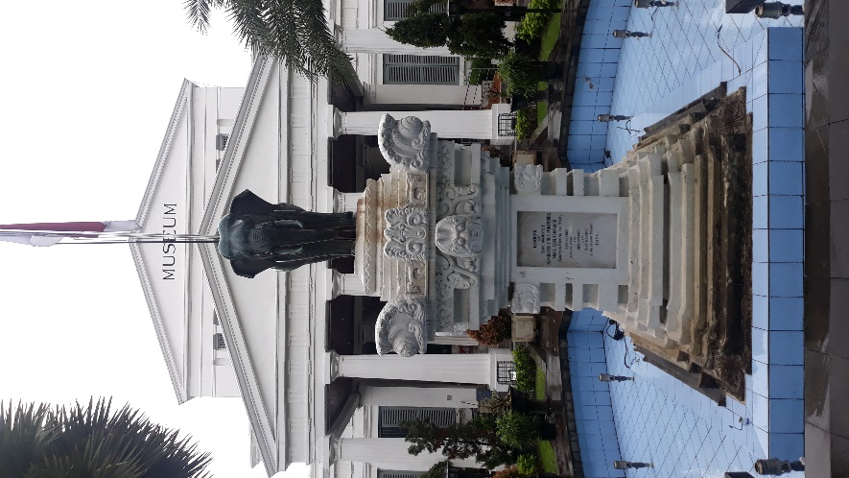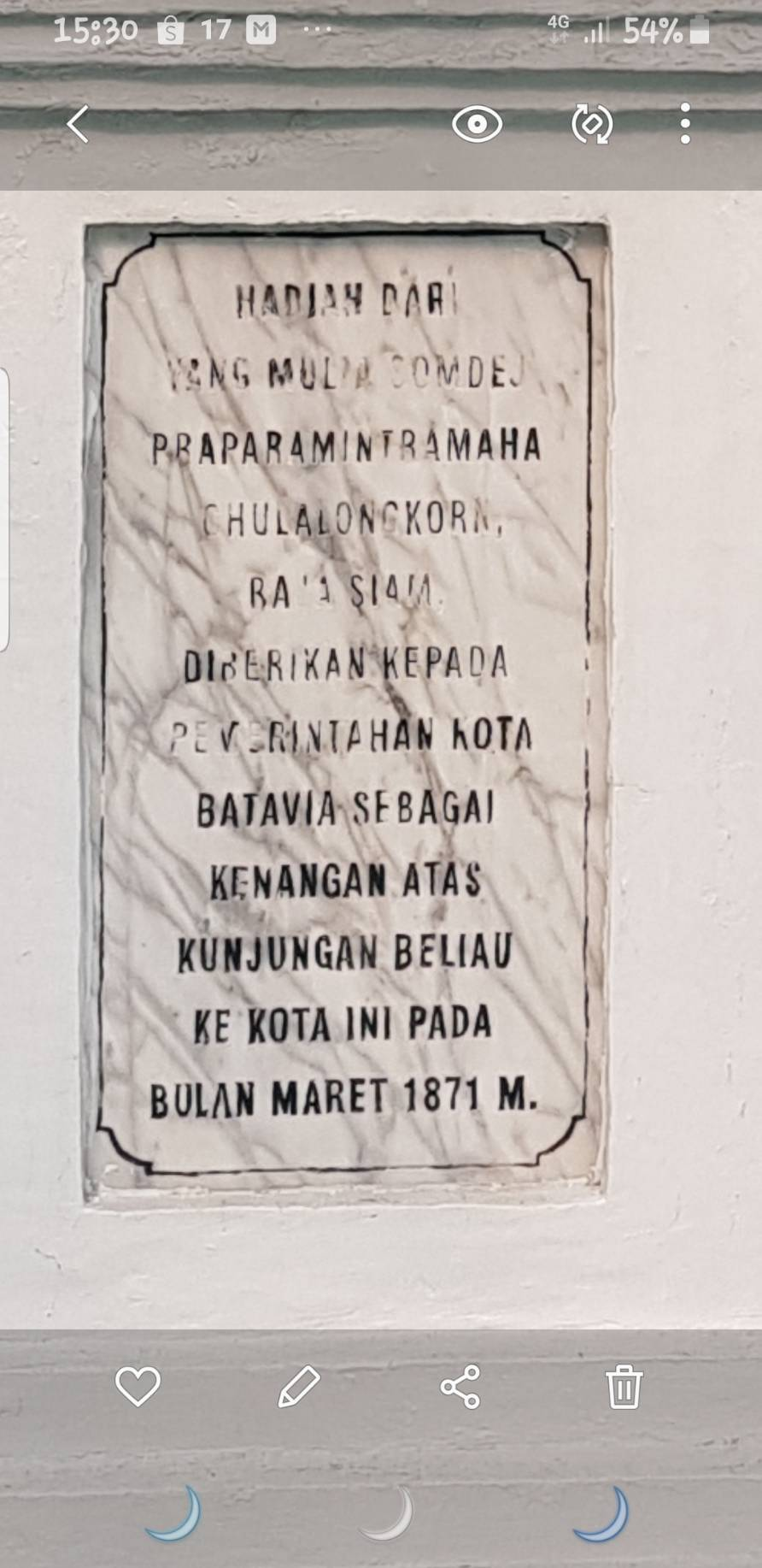

Figure 1: The bronze elephant statue in front of the National Museum, Jakarta.

Source: Surasak Jamnongsan, 2020.

- The second royal visit of King Chulalongkorn to Java in 1896 occurred via Singapore by the Maha Chakri royal yacht. For this visit, His Majesty’s stay in Java was regarded as considerably longer than the first visit. His Majesty visited major towns in Java, including Batavia (Jakarta) and Buitenzorg (Bogor), which were the Netherlands administrative center of Java, Yogyakarta and Surakarta or Solo, which were the two cities where the important palaces of the Mataram Kingdom of Java were located, Surabaya, Kediri, and so on. He observed Java’s various activities, including railways, postal service, the military, education, public health, art, music, and dance. He met Sri Sultan Hamengkubuwono VII, the ruler of Yogyakarta, and Susuhunan, the ruler of Surakarta, who was Pakubawana X.

- The third royal visit of King Chulalongkorn to Java occurred in 1901. On May 5, 1901, he departed Bangkok via Singapore by the Maha Chakri royal yacht. He traveled from West Java to Central Java and East Java before returning to West Java’s Bandung City to board the royal ship from Batavia to Thailand. During this visit, His Majesty had considerable interest in the military and public health. Additionally, Susuhunan Pakubawana X, the ruler of Surakarta, or Solo, and the former host of His Majesty in Surakarta, was honored.

- In 1929, King Prajadhipok and Queen Rambhai Barni embarked on a royal excursion to Java, commencing in Singapore and traveling to Java and Bali by Maha Chakri II royal yacht. Susuhunan Pakubawana X of the Surakarta Court presented a complete set of Javanese gamelan musical instruments during this visit. Mangkunegoro also presented a collection of Javanese dancing garments, which were then transported from Semarang by ship. This set of Javanese gamelan music is the first Javanese gamelan in Thailand.

**The Javanese Gamelan Repertoire Commemorating King Chulalongkorn of Thailand**

In 1870 and 1901, during the last two of King Chulalongkorn’s three visits to Java, he visited the court of Surakarta or Solo, where Suhunan Pakubawana X reigned. He was honored by the Surakarta court by composing Javanese gamelan music for him, which was documented in the Wedhapradangga or Serat Saking Gotek musical archives.

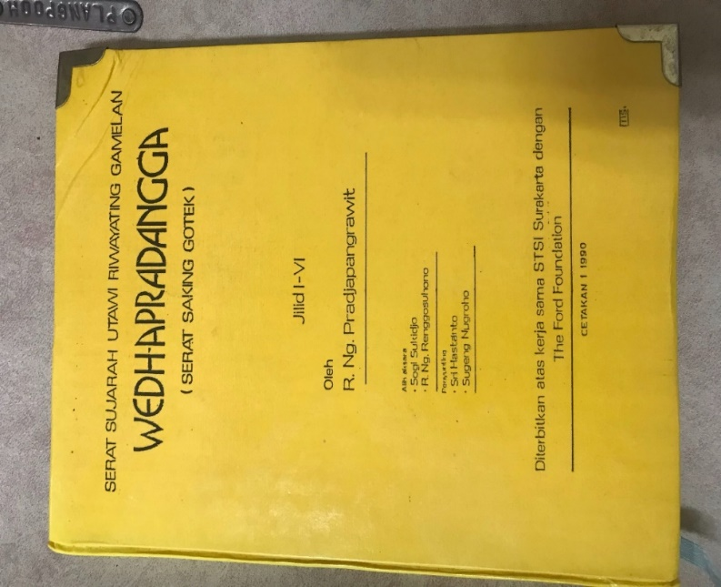

Figure 2: Serat Sujjarah Utawi Riwating Gamelan Wedhapradangga[5] (Serat Saking Gotek)

Source: Pradjapangrawit, R. Ng. (1990), Wedhapradangga.

The Wedhapradangga or Serat Saking Gotek, a Javanese musical archive, comprised of six volumes and was authored by R.Ng. Pradjapangrawit, a musical aristocrat from Surakarta palace, with Javanese script. The archive details the history of numerous Javanese Gamelan musical repertoires, some of which were composed to greet noble visitors and foreign royal guests, such as the arrival of Thai monarchs. The details of the musical composition and performances to honor Thailand’s royal visit are given below:

**Panembrama**

*…Panembrama nalika rawuhipun Sri naranata ing nagari Siyam, Kitha Bangkok, ingkang ajejuluk Sang Maha Silalon Prabu Koren Praculasom Klowa. Rawuhipun ing Surakarta amarengi ing dinten Senen Pon, tanggal kaping 25 wulan Sura ing warsa Jimakir angka 1826 (1896).* (Pradjapangrawit, 1990, p. 150)…

The translated version of the above passage is:

Panembrama – the instrumental and vocal music of Java – was performed to honor the King of Siam from Bangkok, that is, His Majesty the King Chulalongkorn, upon his arrival to Surakarta city on Monday-Pon[6] 25, of Sura month, Jimakir year, 1826 Javanese Era[7] (AD 1896). (Equivalent of July 6, 1896)[8]

**Ladrang Sri Manulya**

*. . . Sri Minulya (ladrangan) raras slendro pathet sanga. Mengeti rawuhipun sri naranata ing Nagari Siyem (raja Siyem rawuh ingkang kaping kalih) dhumateng ing Karaton Surakarta. Jelukipun Sri Maharaja Siyem wau Somdhet Prabat Paramendro; Mahasilalon Prabu Koren Praculasomklowa. Asung pratandhaning sih bintang Groot Kries Kroon Order ing Siyem. Amarengi ing dinten malem Akad Pahing, tanggal kaping 11 Mulud ing tahun Dal 1831 wuku sinta, utawi kaping 30 Juli 1901.* (Pradjapangrawit, 1990, p. 154)…

The translated version of the above passage is:

Sri Manulya, a Ladrangan musical piece of the Slendro tuning system, Sanga tonal cluster, was played to acknowledge the arrival of the King of Siam (King Rama V’s 2nd visit) to the royal palace of Surakarta. The name of the king of Siam was His Majesty the King Chulalongkorn. To commemorate the visit of His Majesty, the King bestowed a royal regalia of Siam. The King arrived at night just before Sunday-Pahing on the 11th of Mulud[9] month, Dal[10] year, 1831 Javanese Era, Sinta segment (wuku[11] Sinta), 30th July 1901. (However, H.M. the King Chulalongkorn’s writing suggested the date to be 30th June, AD 1901)

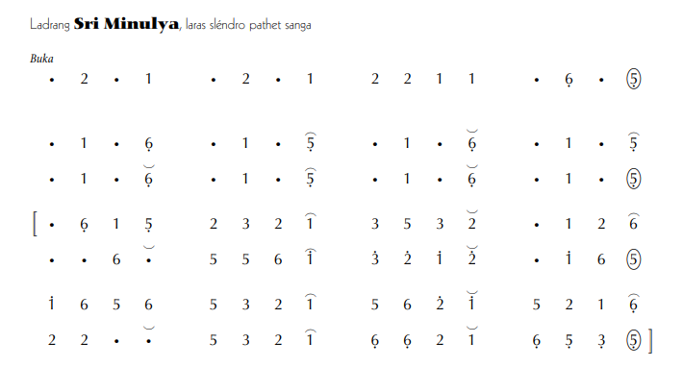

Figure 3: Ladrang Sri Minulya in Javanese Kepatihan Notation

Source: www.gamelanbvg.com. (2020), (Online).

**Ladrang Siyem: Thai Royal Anthem to the Javanese Repertoire in Honor of the King of Thailand**

Ladrang Siyem, or Ladrang Siam, is an arrangement of Thailand or Siam's Royal Anthem or *Sansoen Phra Barami* (Thai: สรรเสริญพระบารมี) into a format suitable for Gamelan by royal families of Java and music virtuosos from the Royal Court of Surakarta. The original score of the military band version of the composition from Thailand was rearranged employing the Javanese style of musical composition (Sumarsam, 2003, p.285). Ladrang Siyem, or the Javanese variation of the Thai Royal Anthem, is one of the songs performed in honor of His Majesty King Prajadhipok, King Rama VII of Thailand, who arrived in 1929 with the Queen. However, it is possible that this was not the first time that Java ever rearranged Siam’s Royal Anthem to compose songs to reinforce good relations between the three parties: the Kingdom of Siam, the Javanese court, and the Dutch colonial ruler. Earlier in the year 1896, an unidentified Western Band (presumably a marching band) of the Batavia officials had already once used to compose “Thai March” based on the Royal Anthem of Siam in order to honor H.M. the King Chulalongkorn during his second visit to Java at Concordia Club (Imtip Pattajoti Suharto, 2010, p. 42). The book Wedhapradangga, which contains information from Serat Saking Gotek, also includes the following statement regarding the history of the song Ladrang Siyem:

*... Ladrang Siyem(2), Slendro pathet nem. Pengetan nalika katamuan Sang Maharaja Prabu Yadipa Sukadhaya Ingkang Kaping VII, narendra Nagari Siyem, sakaliyan prameswari. Amarengi ing dinten melem Rebo Kliwon, tanggal 29 Mulud Ehe 1860.utawi 3-4 September 1929. Ladrang Siyem wau anggitan: 1. Kangjeng Wiryadiningrat; 2.Raden Ngabehi Atmamardawa; 3.Raden Ngabehi Wirapradangga; tuwin 4. Mas Lurah Reksapangrawit (Mlayaresaka).* (Pradjapangrawit, 1990, p. 161) …

The translated version of the above statement is:

Ladrang Siyem, a slendro scale, Nem tonal cluster composition, was performed to honor the arrival of the royal guests, His Majesty the Prajadhipok, the 7th King of Siam, and the Queen, on the evening of Wednesday-Kliwon, 29 Mulud, 1860 Javanese Era. The date described falls between September 3 and September 4, 1929. The Ladrang Siyem was composed by 1. Kangjeng Wiryadiningrat; 2. Raden Ngabehi[12] Atmamardawa; 3. Raden Ngabehi Wirapradangga; and 4. Mas Lurah Reksapangrawit (Mlayaresaka).

**Vocal Notation of Ladrang Siyem**

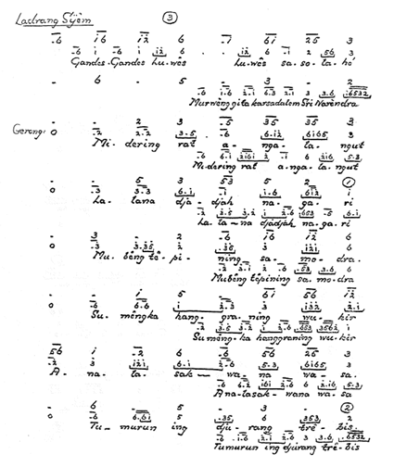

# Figure 4: The Vocal Notation of Ladrang Siyem by K. P. H. Notoprojo

Source:: The Vocal Notation of K.R.T Wasitodiningrat

**Royal Anthem of Thailand or *Sansoen Phra Barami* in Western Staff Notation**

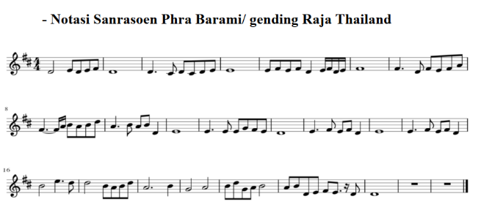

Figure 5: Royal Anthem of Thailand or *Sansoen Phra Barami* in Western Staff Notation

Source: Surasak Jamnongsan, 2015.

**Ladrang Siyem in Western Staff Notation**

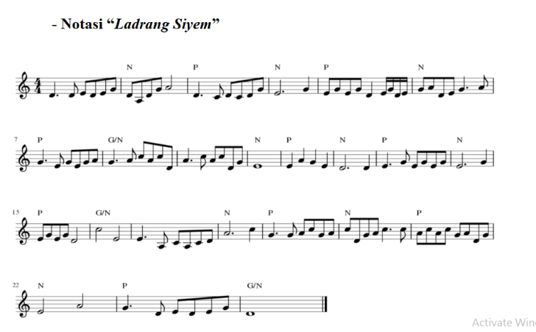

Figure 6: Ladrang Siyem in Western Staff Notation

Source: Surasak Jamnongsan, 2015.

**Ladrang Siyem in Javanese Kepatihan Notation**

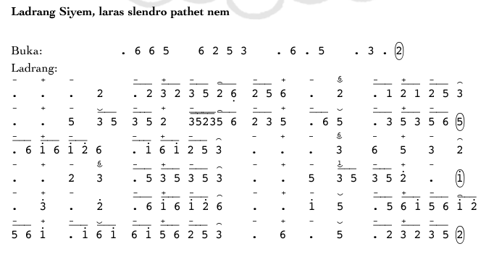

Figure 7: Ladrang Siyem in Javanese Kepatihan Notation

Source: https://www.langensuka.asn.au/

**Conclusion**

The Thailand Royal Anthem, also known as Sansoen Phra Barami, is a musical composition that pays tribute to the King of Thailand and was created in the style of Western classical music. At the time, Thailand modernized itself by identifying with the ‘West’ or Westernization, so Western musical concepts were employed. The song ‘Sansoen Phra Barami’ was then Javanized by musical artists at the Surakarta Palace to be played with gamelan, becoming the piece ‘Ladrang Siyem.’ However, the results of these arrangements do not accurately represent Thai music.

It is generally accepted that gamelan music’s tone system, fundamental notes, and frequencies are different from those of Western music. Several notes must be improved in order to transform the Western-tonal composition ‘Sansoen Phra Barami’ into ‘Ladrang Siyem’ for play on the Javanese gamelan. However, this is not transposed; only a few notes are presented to match the tuning of the gamelan. In addition, the fifth chord is always omitted when Ladrang Siyem is performed with Javanese gamelan because the tuning range of Javanese gamelan instruments does not include the low frequency of the fifth chord. It is challenging to maintain the intonation of the original song, namely Sansoen Phra Barami. The composer of the composition ‘Ladrang Siyem’ purposefully transposed the B note, originally present in the composition ‘Sansoen Phra Barami’, to the C note in ‘Ladrang Siyem’, while ensuring that the transposition remained within the gamelan's tonal range.

The perspective from the music context is a limited picture that is straightforward to comprehend with musicology knowledge. On the other hand, an archive titled ‘Serat Saking Gotek’ mentions the composition of a musical piece based on the Royal Anthem of Siam, ‘Ladrang Siyem,’ by the Surakarta Royal Court, but also presents a description of a musical composition composed to greet the royal families of Cambodia and other countries when they visited Java around the same time. This means the text also discusses political movements in Southeast Asia during the colonial era.

**Bibliographies**

Cherdchoo, W. (2010). *Javanese term in traditional*

*Thai music (Kham Dontri Thai Chue Sai Jawa).* Pitsanulok: Naresuan University.

Chulalongkorn, H.M. King. (2012). *The duration of*

*the travel to Java exceeded a period of two months (Raya Thang Thiew Jawa Kwa Song Deaun).* Bangkok: Saengdao.

Daimond, J. (1995). *The Vocal Notation of K.R.T Wasitodiningrat Volume l: Slendro*. Berkeley: The American Gamelan Institute.

Hughes, D. W. (1992). T*hai Music in Java, Javanese*

*Music in Thailand: Two Case Studies,* British Journal of Ethnomusicology, 1(1), 17-30.

Na Pombejra, D. (2008). *Javanese Horses for the*

*Court of Ayutthaya.* In Breeds of Empire: The "Invention" of the Horse in Southeast Asia and Southern Africa, 1500-1950. Nordic Institute of Asian Studies: Studies in Asian.

National Archives of Thailand. (1908). *The*

*Journey to Java by H.R.H. Bhanurangsi.* Bangkok: National Archives of Thailand.

National Archives of Thailand. (1929). *Transport of*

*Susuhunan and Mangkunedoro's Gamelan ensemble and theatrical costumes.* Bangkok: National Achives of Thailand.

Pattajoti Suharto, I. (2012). ***The Journey to Java by a Siamese King***. Bandung: ITB Press.

Pradjapangrawit, R. Ng. (1990). *Serat Sujjarah*

*Utawi Riwating Gamelan Wedhapradangga (Serat Saking Gotek)*. Surakarta: STSI Surakarta dan Ford Foundation.

Purwodiningrat, K.R.T. Advisor on music to the

Yogyakarta Royal Palace. Interview, February 2, 2015.

Ricklefs, M. C. (2001). *A History of Modern Indonesia since c.1200.* Houndmills: Palgrave.

Soedarsono, R.M. and Tati Narawati. (2011), *Dramatari di Indonesia, Kontinuitas dan Perubahan*. Yogyakarta: Gadjah Mada University Press.

Sumarsam. (2003), *Gamelan: Interaksi Budaya dan Perkembangan Musikal di Jawa*. Yogyakarta: Pustaka Pelajar.

1. Assistant Professor Dr., Director of Graduate Program in Thai and Asian Music, Faculty of Fine Arts, Srinakharinwirot University. Author e-mail: surasakja@g.swu.ac.th
2. Dr., Head of Department of Arts and Cultural Management Innovation, Faculty of Fine Arts, Srinakharinwirot University. Corresponding Author e-mail: phunchita@g.swu.ac.th
3. Lecturer, Department of Thai and Asian Music, Faculty of Fine Arts, Srinakharinwirot University. Corresponding Author e-mail: yotin@g.swu.ac.th
4. Bima Kurda, also known as Bimo Kurdo, is a type of Ladrang composition performed to accompany Javanese sword performances. Beksan Wireng Banda Yuda, or the courage against the war, of the Surakarta Royal Court (Kasunanan), and Beksan Wireng Banda Baya, or the courage against peril, of the Yogyakarta Royal Front Court (Pakualaman), are two additional theatrical productions that employ Bima Kurda.
5. Serat Sujjarah Utawi Riwating Gamelan Wedhapradangga (Serat Saking Gotek), inscribed in Javanese script by R. Ng. Pradjapangrawit, is Java's musical archive. A group of academicians later deciphered the archives and published them in Roman script in a book titled Wedhapradangga in 1990.
6. The Javanese five-day week, known as Pasaran or Pancawara, consists of Legi, Pahing, Pon, Wege, and Kliwon, which coexist with the common Gregorian seven-day week or Saptawara. If today is Sunday-Legi, then tomorrow will be Monday-Pahing, followed by Tuesday-Pon, and so on. The system's cycle is completed every 35 days. For instance, if today is Wednesday-Kliwon, the Wednesday-Kliwon will repeat after 35 days.
7. The Javanese calendar was based on a particular era of the lunar calendar and was adopted following the Saka era of the solar calendar. As the Javanese calendar is lunar, its years are shorter than those of the Saka calendar, which is a solar calendar. The Javanese calendar has more years than the Saka calendar, which is currently in use by the Balinese Hindu community.
8. Compared with the 100-Year Lunar Calendar.
9. The Mulud Month, or Rabi’ al-awwal month, is when Muslims celebrate the birthday of the prophet Mohammad. The specific day is the 12th day of Mulud month. Javanese people will organize a seven-day and seven-night festival around important mosques, such as Masjid Agung, in front of the city’s Royal Palace. The festival is called Sekaten of Sekatenan.
10. Javanese years are organized into a cycle (windu) of 8 years. Dal is the 5th year, whereas Jimakir is the 8th year of each windu. One Windu has eight years with the following names: Alip year, Ehe year, Jimawal year, Je year, Dal year, Be year, Wawu year, and Jimakir year. Windu has four Windu cycles: Windu Adi, Windu Kunthara, Windu Sengara, and Windu Sancaya. Therefore, the process takes four cycles: one cycle is eight years, and one round takes 32 years. Windu is no longer commonly used in horoscopy, but it was once used to forecast future events and predict trends, such as social issues, natural disasters, and other warnings.
11. The Wuku system is a traditional Javanese way of dividing a calendar year into 30 segments known as Wukus. Each wuku contains seven different days and is given a particular name, e.g., Wuku Sinta, which is the 1st Wuku. After a total of 210 days, or 30 Wuku, have passed, the cycle starts anew, beginning with 1st segment again, which is Wuku Sinta, then Wuku Landep, Wuku Wukir, and so on, until all 30 segments have been completed.
12. An official designation is given to a courtier