**List of Interviewees**

1. **Yus Wiradiredja** – 65 years old, Composer, songwriter, lecturer at the Indonesian Institute of the Arts and Culture (ISBI) Bandung, and recognized maestro of *Cianjuran* vocal music. Resides in Bandung. Interviewed at ISBI Bandung in 2015 and 2025.
2. **Neneng Dinar, S.IP., M.Si.** – *Juru kawih* and *Cianjuran* vocalist. Resides in Bandung. Interview conducted at the West Java Office of Tourism and Culture (*Disparbud Jawa Barat*) in 2019.
3. **(Late) Ubun R. Kubarsah** – Aged 57 at the time of interview, Sundanese cultural figure and head of Dasentra (Sundanese cultural center). Resided in Bandung. Interviews conducted in Antapani, Bandung, in 2015 and 2016.
4. **(Late) Zahir Zachri, H., Ir., MA.** – Aged 66 at the time of interview, expert in community education at the Human Resources Development Agency, Ministry of Agriculture, and a prominent figure in Sundanese culture. Resided in Lembang, West Bandung Regency. Interviewed in Antapani, Bandung, in 2015.
5. **Rita Tila, S.Pd., M.Sn.** – Sundanese singer (*sinden*). Resides in Bandung. Interview conducted at Cibaduyut Indah Housing Complex, Bandung, in 2015.
6. **Indra Ridwan** – Aged 57 at the time of interview, Ethnomusicologist and Lecturer in the Department of Karawitan Music, ISBI Bandung. Interviewed at ISBI Bandung in 2016.
7. **Rosyanti** – *Cianjuran* vocalist. Resides in West Bandung Regency. Interview conducted at RRI (Radio Republik Indonesia) Bandung in 2016.
8. **Dian Hendrayana** – Sundanese active audience and Lecturer at the Faculty of Sundanese Language and Literature, Indonesia University of Education (UPI) Bandung. Resides in Bandung Regency. Interview conducted in Antapani, Bandung, in 2015.
9. **Endah Irawan** – Ethnomusicologist and Lecturer in the Department of Karawitan Music, ISBI Bandung. Resides in Bandung Regency. Interview conducted at GBA Housing Complex in 2018.

**DOCUMENTATION DURING AN INTERVIEWS**

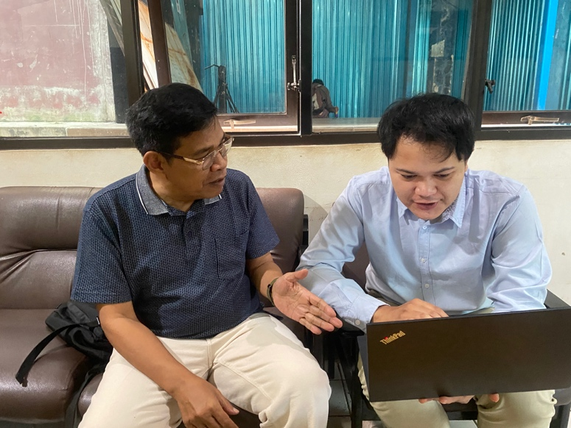

(Personal documentation during an interview with Yus Wiradiredja, the composer of the song Kuring Leungiteun. The photo was taken at the Indonesian Institute of the Arts and Culture (ISBI) Bandung, November 2025)

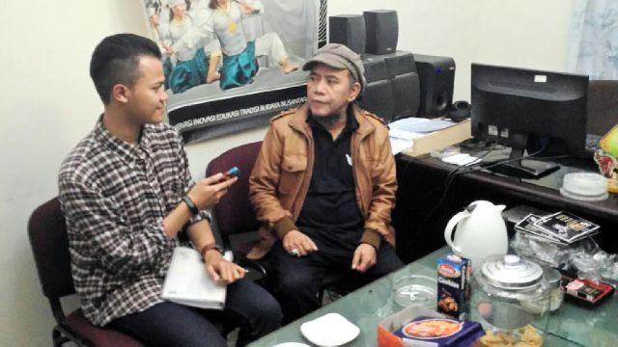

(Personal documentation of the late Ubun R. Kubarsah, cultural figure and director of Dasentra. Interviews were conducted at his residence in Antapani, Bandung, during 2015 and 2016.)

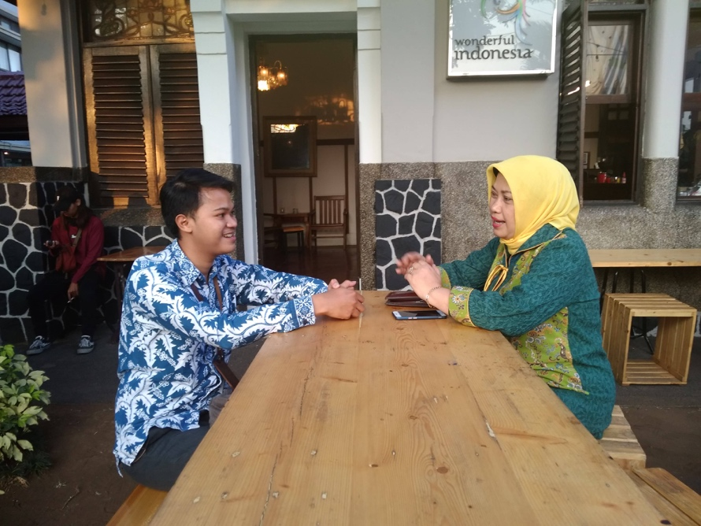

(Personal documentation during an interview with Neneng Dinar, S.IP., M.Si., a prominent juru kawih and Tembang Sunda vocalist. The interview took place at the West Java Department of Tourism and Culture (Disparbud Jawa Barat), Bandung, December 2019.)

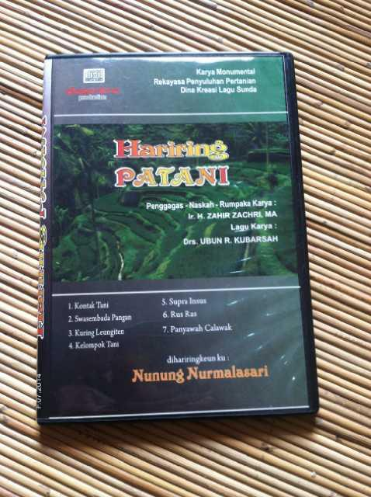

(VCD album titled Hariring Patani, containing a collection of songs created as part of an agricultural extension strategy to promote rice self-sufficiency (Swa Sembada Beras). Private collection.)

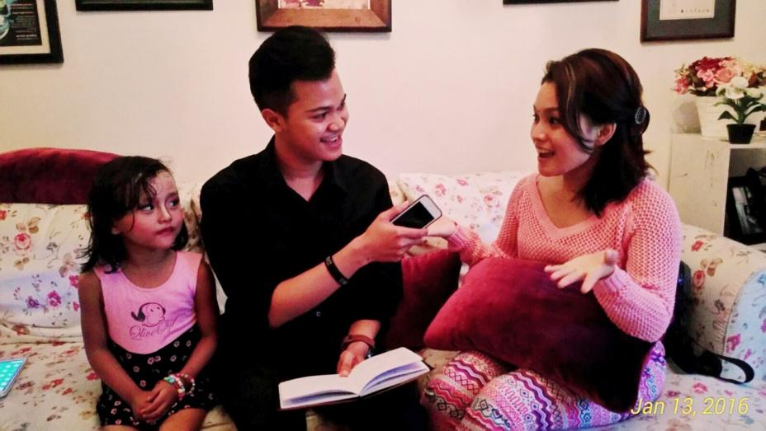

(Personal documentation during an interview with Rita Tila, S.Pd., M.Sn., a Sundanese singer (*sinden*) known for her vocal versatility. Interview held at Cibaduyut Indah Housing Complex, Bandung, October 2015.)

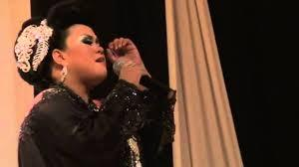

(Personal documentation of Rosyanti performing *Kuring Leungiteun* at the Mayang Sunda Cultural Stage, Bandung City, in 2013. Observed directly by the researcher.)

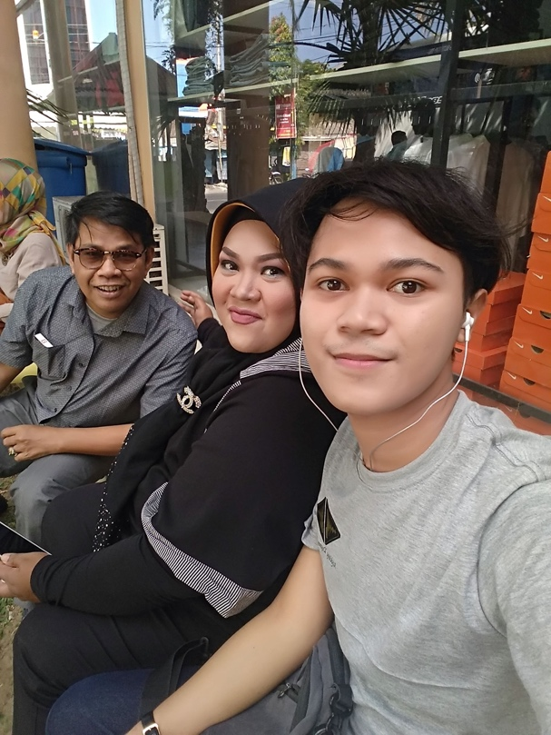

(Personal documentation during an interview with Rosyanti and Yus Wiradiredja before performed at International Gamelan Festival at Solo, 2018.)